MINI PROJECT REPORT

On

BRAIN TUMOR DETECTION

Submitted by

Pankhuri Srivastava
University Roll no. – 181520027

Department of Computer Engineering & Applications
Institute of Engineering & Technology



GLA University
Mathura- 281406, INDIA
2020

TABLE OF CONTENTS

1.Acknowledgement -------------------------------------------------- 2

2. Overview ------------------------------------------------------------- 3

3. Abstract -------------------------------------------------------------- 4

4. Software Requirement Specifications -------------------------- 5
i) Hardware Requirements ------------------------------------------------------------------ 5
ii) Software Requirements ------------------------------------------------------------------- 5

5. System Design ------------------------------------------------------- 6
i) Introduction -------------------------------------------------------------------------- 6
ii)System Architecture---------------------------------------------------------------- 7
iii)UML Diagram------------------------------------------------------------------------ 8
iv)Convolution Neural Network---------------------------------------------------- 9

6. System Analysis ---------------------------------------------------- 12
i) Introduction------------------------------------------------------------------------ 12
ii) System Used And It’s Advantages-------------------------------------------- 12
iii) Objective-------------------------------------------------------------------------- 13
iv) Cost Benefit Analysis----------------------------------------------------------- 13

7. Conclusion ---------------------------------------------------------- 15
ACKNOWLEDGEMENT

Presentation, inspiration and motivation have always played a key role in the success of any venture.

We would like to express sincere gratitude to our teachers, to encourage us to the highest peak, to provide us the opportunity to prepare this project and for providing their invaluable guidance and suggestions throughout the course of project. We are highly indebted to their constant supervision as well as for providing necessary information regarding the project and also their support in completing the project. We would also like to express our special gratitude towards our friends for their kind co-operation and encouragement which helped us in completion of this project.

Last, but not the least, our parents are also an important inspiration to us.
So with due regards, We express our gratitude to them.

OVERVIEW

As part of the project, We successfully completed the project titled – "Brain Tumor Classification” which helped in developing a deeper understanding on how to develop, evaluate, and use deep convolutional neural networks for image classification from scratch.
A Convolutional Neural network using Sequential model API was built with Keras by repeating a few layers of a neural layer followed by a pooling layer then a dropout layer.
Throughout this training, Python programming language in Jupyter/Google Colab platform was used along with various machine learning/deep learning libraries such as matplotlib, Numpy, etc. This capstone project work developed skills such as - exploration of various techniques in data pre-processing, ways to mitigate data overfitting, efficient and thrifty hyperparameter search and formed the basis of how to develop a robust test harness for estimating the performance of the model, explore improvements to the model and how to make predictions on new data.

ABSTRACT

Brain Tumor Segmentation is one of the most crucial and arduous tasks in the terrain of medical image processing as a human-assisted manual classification can result in inaccurate prediction and diagnosis. Brain tumours are two types:
- Malignant
- Benign
Most of the disease will reach the critical stage if not detected earlier. Timely detection of the disease will help a lot in the treatment process. The major cause of brain tumours is because of the abnormal growth and uncontrolled cell division in the brain. Pituitary, Meningioma and Glioma are some of the common types of tumours. We will use the MR images of the brain to predict the pattern of the tumour with the help of machine learning techniques which makes the process less time consuming with the minimal amount of errors. Basically the MR images are taken in three different directions for brains:
- Axial,
- Coronal
- Sagittal.
These three images are analysed by the model to detect the tumour.We investigate the role of CNNs to segment brain tumours by firstly taking an educational look at CNNs and perform a literature search to determine an example pipeline for segmentation.

SOFTWARE REQUIREMENT SPECIFICATIONS

Hardware Requirements-
The most common set of requirements defined by any operating system or software application is the physical computer resources, also known as hardware. A hardware requirements list is often accompanied by a hardware compatibility list (HCL), especially in case of operating systems. The basic hardware requirements is-
- Laptop (above i3 Processor) with at least 4GB RAM
- GPU (usually preferred) with 1.5GHZ Processor with good internet connection.

Software Requirements-
Software engineering Technology defines a software requirement as a condition or capability needed by a user to solve a problem or achieve an objective. The basic software requirements is
- Window OS/Linux Distribution/Mac OS
- Python 3
- Jupyter Notebook
- Anaconda Distrbution

SYSTEM DESIGN

INTRODUCTION
System design is the process of defining the architecture, components, modules, interfaces, and data for a system to satisfy specifies requirements. System design could be as seen as the application of systems theory to product development. It is about the physical organisation of the system. It is demonstrated with the help of UML Diagram or block Diagrams etc. it is explained in a pictorial representation.
Figure 5.a: Pre-processing

SYSTEM ARCHITECTURE
System Architecture
1.Image Acquiring
The Primary Phase is acquiring images. After the Images collection, the obtained images have to be prepared with a wide range of vision.
2. Pre-Processing
The images which are collected are subjected to preprocessing. In Pre-processing stage basic steps are image resizing and applying Gaussian filters for a perfect input clear image for easy identification of an image. 1. Segmentation In this stage of implementation, Pre-processed images will be segmented digitally into various pixels. We do this segmentation for an image is to modify its representation to have more clarity to study and analyse the images.
3.Feature Extraction
In the feature extraction process, we can implement the effective texture operator which labels the pixels of an image. Here we extract the features and characteristics of Images for easy detection of brain tumor.

4.Classification
In Classification stage, Convolutional neural networks algorithm is used for classification of brain images. It is a non-parametric method which is used for both classification and regression.
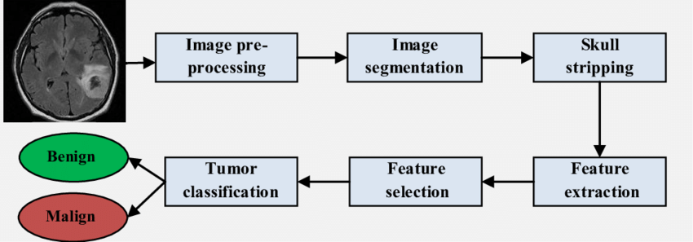

UML Diagrams
The Unified Modelling Language (UML) is a general-purpose modelling language in the field of software engineering, which is designed to provide a standard way to visualize the design of a system. The Unified Modelling Language (UML) offers a way to visualize a system’s architectural blueprints in a diagram.

Use case Diagram for Brain Tumor Detection Using Convolutional Neural Networks
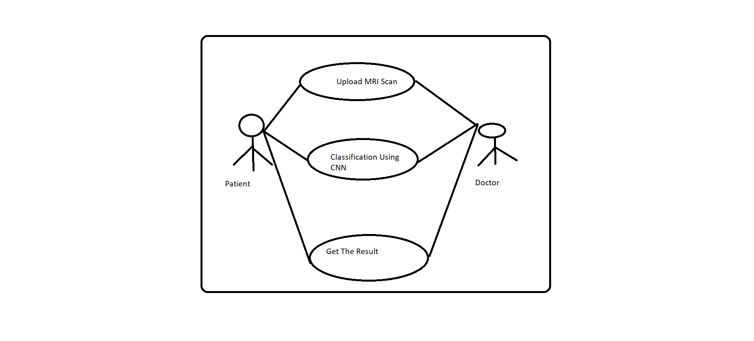
A use case Diagram at its simplest is a representation of a user’s interaction with the system that shows the relationship between the user and the different use cases in which the user is involved. A use case Diagram can identify the different types of users of a system and the different use cases and will often be accompanied by other types of Diagrams as well.

CONVOLUTION NEURAL NETWORK
Convolutional Neural network is a deep learning technique which is feed forward artificial neural networks that are applied to visual images. These are also called as CONV NETS. These are combined set of layers that can be worked on group functionalities.
Convolutional Neural Network

Pooling in Convolutional Neural Network

SYSTEM ANALYSIS

INTRODUCTION

System analysis refers to analyzing the project hardware and software requirements. It isoften done for Diagnostic or troubleshooting purposes. running a system analysis can also behelpful when determining if the project means all the desired requirements.

SYSTEM USED AND ITS ADVANTAGES:

The developed application is very simple and easy to handle and the user can view all thedetails about the hospitals and check whether he has brain tumor or not which makes it easy forthe user to make a quick decision. Scope limitations are restricted in some of the hospitals whichcan be displayed clearly and the patients or the users can book the appointment date and time slotsas per their availability and can also provide their details prior. Everything is available at thefingertips for the user with minimal selections.
The application gain popularity not only by the way it looks but also the way it feels andour project makes the most use of it, since it is based on Convolutional Deep Learning NeuralNetworks.
The proposed system has following advantages:
- Displaying of the information and highlighting the key points which makes thehuge difference with other websites.
- To serve the patient with best possible quality and maximum facilities with less price
- Ensures user satisfaction.

OBJECTIVES

A platform for the Brain tumor detection using Convolutional Neural Networks has the
following objectives:
- To serve its users with best possible quality and provide the maximum facilities with
less price.
- To serve and take well care of our user/patient.
- Ensure user satisfaction.

COST BENEFIT ANALYSIS

15 Cost Benefit Analysis can be explained as a procedure for estimating all costs involved and possible profits to be derived from a business opportunity or proposal. It takes into account both quantitative and qualitative factors for analysis of the value for money for a particular project or investment opportunity. Benefits to costs ratio and other indicators are used to conduct such analyses. The objective is to ascertain the soundness of any investment opportunity and provide a basis for making comparisons with other such proposals. All positives and negatives of the project are first quantified in monetary terms and then adjusted for their time-value to obtain correct estimates for conduct of cost-benefit analysis. Most economists also account for opportunity costs of the investment in the project to get the costs involved. In the economic feasibility, the development cost of creating the system is evaluated against the ultimate benefit derived from the new systems. Financial benefits must equal or exceed the costs. The system is economically feasible because it does not require any addition hardware or software resources. Since the interface for this system is developed using the existing resources and technologies that are available, there is a nominal expenditure and it is economically feasible.

CONCLUSION

This projects consists of the details about the model which was used for the detectionof brain tumor using the MRI images of the brain from the normal persons and the persons who had a brain tumor. From the resultant graphs, it is proven that the accuracy of the model has reached a good level, if it is deployed in the real-time scenario then it will help many people in diagnosing the brain tumor without wasting the money on check-up. If the brain tumor is confirmed by the model, then the person can reach the nearest hospital to get the treatment. It can be the best way of practice for people to save money. As we know that the data plays acrucial role in every deep learning model, if the data is more specific and accurate about thesymptoms of the brain tumor then that can help in reaching greater accuracy with better results in real-time applications.
1. “Brain Tumor Detection using Convolutional Neural Networks” simplifies the management process of brain tumor check-up by deploying a web interface to the users.
2. Fast processing and immediate results with high security.
3. Minimizing human effort and cost efficient databases.
4. Navigation through the site is easy.

